**Gender Discrimination**

A gender-equal society would be one where the word ‘gender’ does not exist: where everyone can be themselves.”

- Gloria Steinem.

**Introduction**

Girls and women primarily suffer from the negative impact of rigid gender norms and roles - they are more likely to experience restrictions on their freedom, decisions, or mobility, they experience epidemic levels of harassment and violence across the globe and have limited opportunities and freedom. But boys and men suffer too. Ideas about what it means to be a “man” forces them to behave in very limited ways which can harm them. Negative masculinities in boy exhorted by the society too serves to perpetuate the cycle of discrimination and inequality.

**What is Gender Discrimination?**

Gender discrimination or Sexism is any unequal treatment, including privilege and priority, based on their gender. It elucidates the situation in which people are critiqued and judged for their actions or thoughts, differently simply because they are male or female, rather than based on their individual skills or capabilities.

Sexism can be conveyed in:

* behaviour
* practices and traditions
* speech
* gestures
* laws and policies

Gender prejudice and resulting gender discrimination begin from the childhood, girls and boys face unequal gender norms regarding expectations and access to resources and opportunities – in their homes, schools, and communities.

For example, boys are often encouraged to go to school and get an education to prepare for work, while girls carry heavy household responsibilities that keep them from school. Thus, denying people the freedom to choose their path in life because of their gender prevents them from fulfilling their full potential.

**Types of Gender Discrimination**

* **Gender stereotypes:**

Gender stereotyping is the *practice* of ascribing to an individual man or woman specific characteristics, attributes, or roles imposing it as a way how societies expect people to act based on their gender rather than their will. For example, girls should dress modestly, should stay at home and help with household chores and childcare, and not stay out late at night. The society often judge people by how well they adhere to the gender stereotypes.

Likewise, seemingly positive stereotypes and gender roles like men being the ‘bread earner’ or ‘protector’ of the family, adds an unnecessary burden on them which could more positively be shared in an equal partnership.

* **Education:**

Educational specialties in higher education perpetuate gender inequality in the society. Stereotypes about the different cognitive abilities of boys and girls, leads to certain school subjects and teaching methods being gendered. Boys are considered better suited to maths, the sciences, technology, and sports whereas girls are considered better suited to the arts and humanities. Thus, curbing the individual from the freedom of pursuing courses of his choice. In a few, gender-segregated schools, certain subjects are not even offered to female students. Parents often spend differently based on gender of their children. The differences in the expenditure include spending inequitable on fees, school supplies like school bags, uniforms, and other expenditures.

Pie Chart from **UNSECO eAtlas Survey** on Gender Disparity in Education

* **Work Place:**

Gender discrimination can take various forms in the workplace –applies to both men and women (although women are the predominate victim). Generally, gender discrimination is when the management or a corporation treats employee differently based on their gender. Work place gender discriminatory actions can be subtle or aggressive, not all discriminating actions are blatant or obvious in the workplace.

Below are some gender discrimination examples:

* Hiring, firing, or promoting someone because of their gender
* Less support from seniors to female employees for their ideas even if well planned considering strategizing is not cup of their tea.
* Female employees are circumscribed from adding their husbands to their health insurance as it is assumed that the husband has his own healthcare benefits, while male employees can add their wives
* Withholding job opportunities from individuals who identify as transsexual or homosexual
* **Earning Gap**: A female works her way up to management finds out that a newly hired male manager (same position and duties) is getting paid more than she is despite equal qualifications.

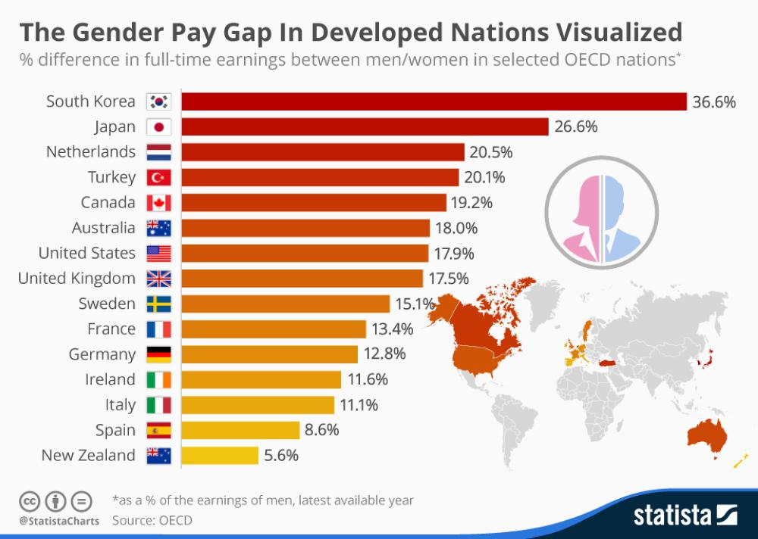

The survey, which was conducted online in English and in Spanish through GfK’s Knowledge Panel included sample of 4,914 adults, ages 18 and older, summarises the results below:

* **Gender-based violence:**

Gender-based violence occurs everywhere around the world across all economic and social groups. Both girls and boys are adversely affected, girls are at striking risk. An estimated 1 in 3 women globally have experienced violence in their lifetime, especially at the hands of their conjugal. Types of violence: female infanticide, rape, forced prostitution, prenatal sex selection, domestic violence. Domestic violence is prevailing and even legally pardoned in many countries. In Peru, 837 girls and women were murdered between 2010 and 2016. Dowry related femicide occurs when a groom’s family is unhappy with the amount of dowry given to them. His wife becomes “inapt” or “unsuitable” in his family’s eyes and she may be tortured and driven to suicide or even killed by the groom’s family. Dowry killings are exponentially increasing in Asian countries, accounting for up to 50 per cent of all female homicides.

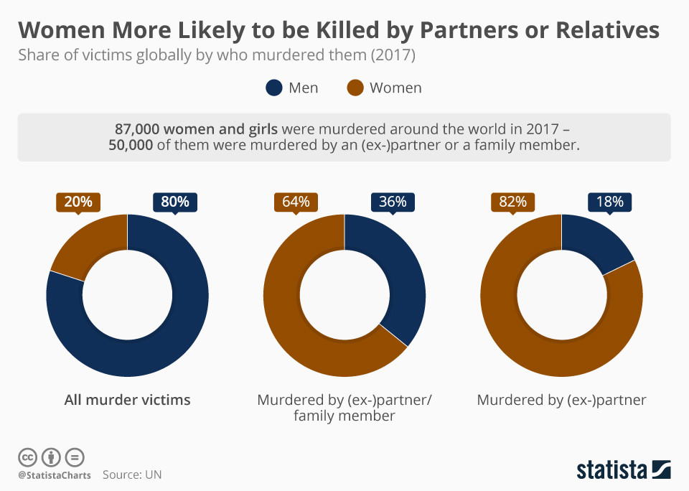

* **Sports:**

A women’s physical strength has! always been considered inferior to men. Gender discrimination begins at home when parents’ are unwilling to allow@ their girl child participate in sports.! There exists unperceived bias in the upbringing of a boy and a girl child. We are taught that girls are not supposed to play in the fields;^ in the open, girls are tender, frail, and might easily get hurt.)Be it kabaddi, weightlifting or wrestling, it’s the boys’ sports. Gifts like football, bat or sports accessories are solely for our brothers. Four prominent female, Bianca-Valenti!, Keala, Andrea Moller, and Paige Alms,! spent years advocating equal pay for same sports.

So, basically the first one is the wage gap. Another problem is picayune media coverage, subject to objectification and sexist comments. Lastly, the society stereotypes! for women athletes.

* **Objectification:**

Objectification is when a person is treated as a! commodity without any regard*to their! personality or dignity. It’s conspicuous in the media where women are photoshopped and airbrushed, in a way giving more emphasis being put on their external appearance above other capacities. This affects girls’ $body image, their self-esteem and ultimately the value that people put. Girls are often represented #poorly in entertainment and the media in ways that reinforce damaging gender stereotypes and traditional roles. The actress’ are forced to dress tawdrily or perform raunchy or intimate scenes, if they refute these perverted demands, they often are fired from the work.

**Real Life Incidents of Gender Discrimination:**

* 62 million girls around the world are denied an education, which often dooms them to a life of poverty and dependence. One of the most famous example is **Malala Yousafzai**. The Taliban organization tried to kill her, to silence her, for going to school. Malala along with two other girls were shot by a Taliban gunman in an assassination attempt in5retaliation for her activism.6Yousafzai was hit in the head with a bullet and remained unconscious and in critical condition

* Saudi Arabia, one of the most gender-unequal countries on Earth. Women do not have Freedom &to Travel or Get a Passport. In Saudi Arabia women were not allowed to drive cars until June 2018. Child Marriages and No Freedom to Choose Marriage Partner. Woman was allowed to contest for a local municipal council seat, neither are allowed to vote, a man was required to back and promote her campaign and male giving speeches on her behalf* when addressing male voters. Like most other Muslim majority *countries, Saudi Arabia bases its personal law system on Islamic law. But Saudi Arabia has no written family law.

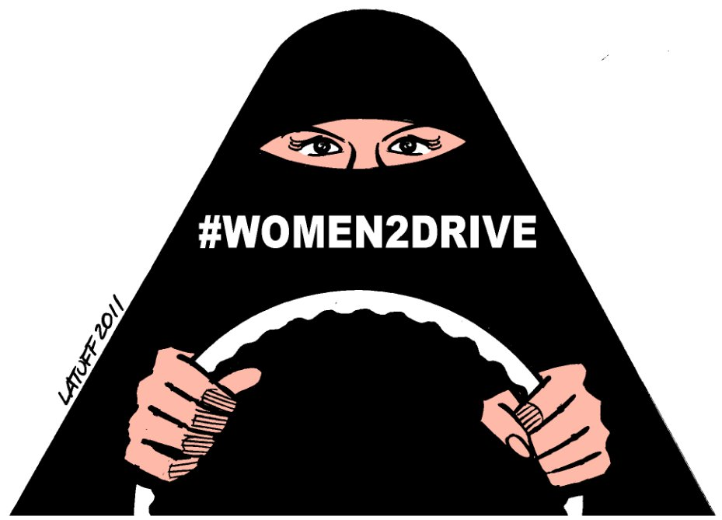

* **PwC** has released a new study into the representation of women across the corporate business world. The report is based on a survey of 328 respondents representing organisations headquartered in 18 difference countries and a survey among 4,792 employees from 70 countries – 82% of the respondents were female and are currently employed or about to start their first job. At entry level there is a discrepancy of 4% on parity in favour of men, this reaches 13% by managerial level, 17% by senior manager/director level, 21% at vice president level and 26% at senior vice president level. When it comes to boardroom positions, the discrepancy at the C-suite stands at 31%

[For further details about the PwC](https://www.consultancy.uk/firms/pwc).

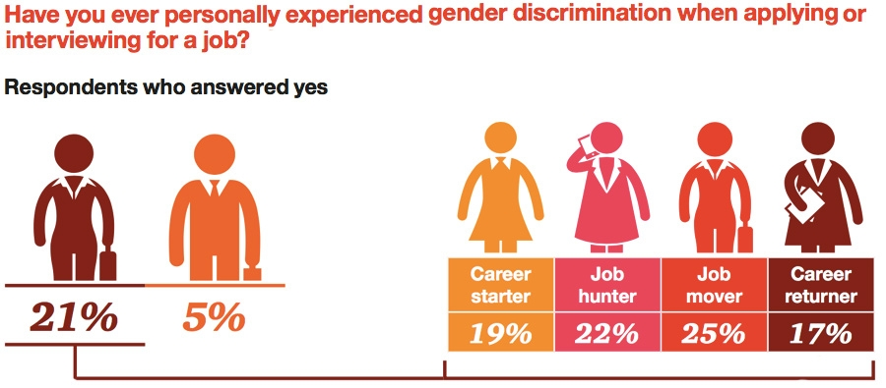

* According to the World Health Organization list, the countries with most frequent **femicide** cases are El Salvador, Venezuela, the Central African Republic, South Africa, Jamaica, Honduras, Guatemala, Guyana and Mexico**.** According to thestatistics conducted by the **United Nations Organization on Drugs and Crime**, the distribution of incidence of femicide by the total number of occurrences (the overall female population) :
  + Asia – approximately 20,000
  + Africa – approximately 19,000
  + The Americas – approximately 8,000
  + Europe – approximately 3,000
  + Oceania – approximately 300

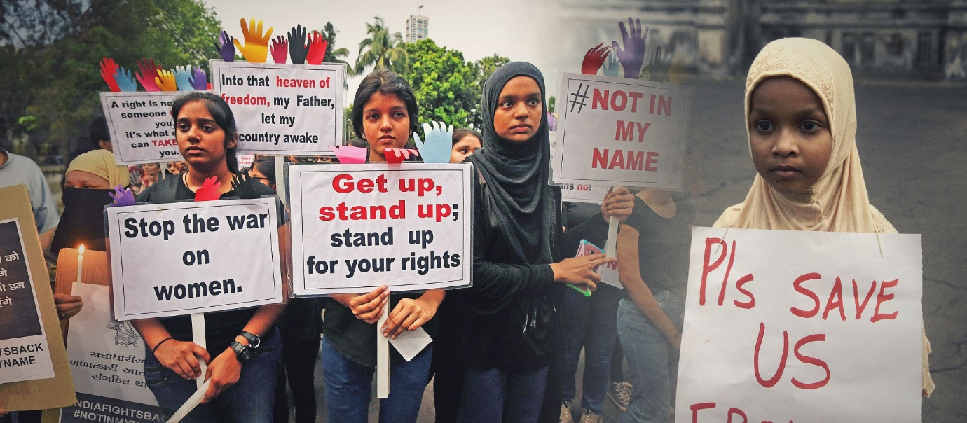

* Indian badminton ace **Jwala Gutta**, the 14-time winner of the National Badminton Championships, compared sports as a career for women akin to walking on a tightrope. They are often victims of Objectification and less support from family, government and unequal pay. In one of her interview with the Economic Times, she said:

*“There is a lot of discrimination. Consider this: whenever a badminton squad is sent for an international meet, there are usually 10 boys and 3-4 girls. Why is it like this? If we have good hair or look good, we are called glamorous and it is presumed that we are not focused on sports,”*

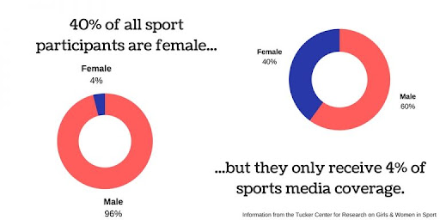

* In a report called **‘The Gender (In)Equality Issue’** by Sports Illustrated Global Sports Salary Survey 2017, from the ‘big five’ divisions of European football in England, Spain, Italy, Germany and France; to football in the CSL or for cricket in the IPL in India or baseball in the NPB in Japan. The male players in earn almost 100 times what their female counterparts earn. Such massive disparity still prevails widely across elite team sport.

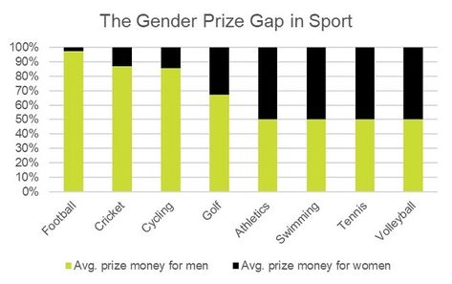

* In most of the other countries, many women are subject to domestic violence. Over a one-year period ending October 1, 2020, the Labour and Social Development reported that it encountered 8,00,016 cases of physical and psychological abuse, most involving violence between spouses.

**Conclusion**

Gender discrimination is any unequal treatment, biased privilege or priority, on the basis of gender. Girls and women primarily suffer from the negative impact of rigid gender norms and roles - they are more likely asked to bridle their decisions or mobility, experience epidemic* levels of harassment and violence across the globe and have limited opportunities and freedom. But boys and men suffer too. Ideas about what it means to be a “man” forces them to behave in very limited ways which can harm them. Negative masculinities encouraged in boys serve to perpetuate* the cycle of inequality’’and discrimination. These are the examples of Gender Stereotypes.

Some other major types of Gender Discrimination discussed in the report are discrimination in work place, where women are not considered fit for high decision making posts or unequal pay, even not getting support from their seniors. Second, in discrimination in sports which begins from the our homes where girls are considered delicate and should not be playing out in the open. Even in the well established professional women players are often shadowed by their male counterparts or are often subject of objectification. Third, inequality in Education, on one hand boys are exhorted to take up higher education, girls are expected to drop out and manage all the household chores. Even in the urban cities girls are allowed to pursue only easier courses like humanities over more technical courses like engineering. Finally, we also have gender violence, both boys and girls are negatively impacted, girls are particularly at risk. The types of violence may include: prenatal sex selection, female infanticide, rape, neglect, domestic violence, forced prostitution.

**Bibliography**

<https://plan-international.org/girls-get-equal/calling-out-discrimination>

<https://www.medicalnewstoday.com/articles/types-of-sexism>

<https://www.right-to-education.org/girlswomen>

<https://www.globalcitizen.org/en/content/x-stories-explore-women-girls-equality/>

<https://www.pewresearch.org/fact-tank/2017/12/14/gender-discrimination-comes-in-many-forms-for-todays-working-women/ft_17-12-13_genderdiscrimination_postgrad/>

<https://bohmlaw.com/areas/gender-discrimination/>

<https://www.consultancy.uk/news/13191/women-continue-to-face-barriers-in-recruitment-and-progression>

<https://www.weforum.org/agenda/2020/11/violence-against-women-femicide-census/>

<https://www.sciencedirect.com/topics/social-sciences/gender-discrimination>

<https://www.ncbi.nlm.nih.gov/pmc/articles/PMC5847257/>

**Plagiarism Checker**

**Part 1**

**Part 2**

